Coin Toss example: a different view

**Maximum Likelyhood (ML) Estimation**

Let P be the probability of heads.

What is the probability of getting k heads given P?

(kHeads|P) = P^k*(1-P)^N^-^k

This equation represents the standard distribution (bell curve) of the results of tossing a coin where the mean is 0.5.

[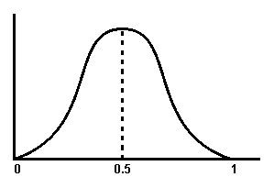](http://www.bioen.utah.edu/wiki/index.php?title=File:BellCurve.png)

The mean is the maximum likelyhood (ML) of getting heads.

**Maximum a Posteri (MAP) Estimation**

The beta distribution formula is used when the coin might be biased.

(P) =\frac{1}{c}*P^\alpha*(1-P)^\beta

Where alpha/\beta is the mean of the beta distribution and where P(P) is at a maximum.

[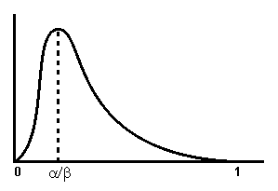](http://www.bioen.utah.edu/wiki/index.php?title=File:BetaDistr.png)

Note that (P|kHeads)=P(kHeads|P)P(P), therefore by substitution:

(P|k heads) = P^k *(1-P)^n^-^k *\frac{1}{c}*P^\alpha*(1-P)^\beta

We solve this for P by taking the log of P and then the derivative of the log with respect to P and we end up with

=\frac{k+\alpha}{N+\alpha+\beta}

Note that alpha and beta are constant, so as the number of tosses becomes very large, alpha and beta become insignificant, and we end up with

 = \frac{k}{N}

In other words, the probability distribution of heads approaches the ideal.

N turns to infinite